**Kinematic analysis of a front flip pike on a mini trampoline**

**Dr. Ahmed Qasim Kadhim1**

*1AlSafwa University College/ Department of Physical Education and Sports Sciences /Iraq.*

***Corresponding authors:***[*ahmed.qasim@alsafwa.edu.iq*](mailto:ahmed.qasim@alsafwa.edu.iq)

**Abstract:**

**Objective**: The aim of this study was to investigate the linear kinematics of the a front flip pike on a mini trampoline.

**Methods**: The study sample was one player In this study, a high-speed digital video camera was used, set to 120 frames per second, and the linear kinematic data were calculated using the Kinovea software. The variables were calculated in six phases.

**Results**: Increase in the horizontal velocity and decrease in the vertical velocity in the contact phase. Increase in the vertical velocity and decrease in the horizontal velocity in the take off phase. Decrease in the displacement values ​​on the horizontal axis and increase in the vertical axis in the rise phase. A significant increase on the horizontal level accompanied by a velocity of the center of mass on the same axis with a continued increase in the displacement values Vertical and decrease in velocity values. In the landing phase, the horizontal displacement continues to increase and the vertical displacement values ​​decrease.

**Conclusion**: It is suggested that players improve to increase the vertical velocity in the take off phase and train to control the limbs perfectly in the air.

**Keywords**: mini trampoline, linear kinematics, maximum height

**1-Introduction:**

Trampoline jumping is a branch of gymnastics and has received a lot of attention like other branches and mini trampolines are fun and exciting for spectators. Moreover, mini trampolines are used in gymnastics education and training and therefore deserve attention from the gymnastics equipment point of view. Mini trampoline jumping consists of five phases, the running phase, the inside jump, the take-off phase, the flight and landing phase [1]. The goal for the gymnast in trampoline jumping is to achieve a higher center of mass to allow for the execution of difficult exercises. During learning, a higher center of mass leads to longer air time to practice new movement sequences[2] .

**Mini-trampoline** starting distance Gymnasts can freely choose the distance of their run. The only restrictions are the dimensions of the gymnasiums, other equipment, stands or other infrastructure at the competition site. A minimum run length of 20 m can be expected at national level. According to Bechter and Krieger (2011), the mini-trampoline start is done in a continuous upward trajectory on the forefoot, with the upper body and head in an upright position. In artistic gymnastics, the main focus of this approach is on “producing enough force”[3].

**Entry/jump.** According to Bechter and Krieger (2011), the jump should be done after running on the mini-trampoline with the lowest possible jump angle. The position of the legs and hips during the jump is depicted, in gymnastics language in STV (2016), as slightly bent. The arms are in a forward position. You then jump off the mini-trampoline with your legs and hips extended. The arms are in a raised position (see Figure 4). According to Gerling (2008), in free jumps without a vaulting table in artistic gymnastics, a small jump angle α to the horizontal leads to a large jump angle β. This is the case when gymnasts with strong reserves intervene. A high take-off angle β leads to a high flight height. On the other hand, the smaller the take-off angle β, the higher the rotational speed. The reason for this is the increase in the horizontal distance a from the center of mass (CM) to the take-off point (see Figure 4). Gymnasts should always aim for the optimal take-off angle for the planned jump, at which sufficient rotational speed and jump height can be generated. According to general knowledge, the statements about jumping on and off vaulting platforms in artistic gymnastics by Gerling (2008) also apply to jumping on and off mini-trampolines. Figure 3 illustrates this relationship between entry and take-off angles.

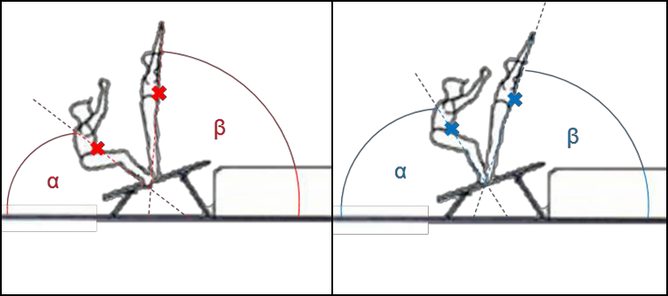

**Figure 1.** Common concept of the relationship between the entry and the take-off (red: small entry angle = large take-off angle; blue: large entry angle = small take-off angle). Adopted and adapted from the Swiss Gymnastics Federation, 2016, p. 3, chapter Jumps.

However, the relationship between entry and take-off angles has not been scientifically examined and therefore needs to be examined. It should be noted that the time between jumping and landing on a mini-trampoline is longer than on a diving board (Gerling, 2008) and that the angle of inclination of the diving board is different from that of a mini-trampoline. In artistic gymnastics, the springboard jump is followed by a push with the hands on the diving board. In gymnastics, the freestyle jump follows immediately after the jump. Schurer et al. (2016) claim that jumping with a small take-off angle is a common mistake in gymnastics. They see a possible reason for this as jumping too close to the mini-trampoline. Gymnasts will leave the mini-trampoline with too much support instead of in an upright position.

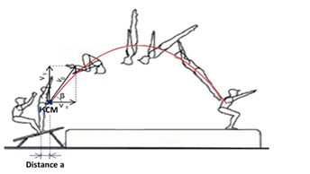

**Figure 2.** Parabolic flight curve of the CM during a mini trampoline jump, forward somersault while tucked, including the prevailing speeds when leaving the mini trampoline. vy = vertical speed. vx = horizontal speed. v0 = initial speed. β = take-off angle. CM = body center of gravity. Adopted and adapted from the Swiss Gymnastics Federation, 2016, p. 3, chapter Jumps.

**Flight phase.** After jumping from the mini-trampoline, the flight phase follows. According to Bechter and Krieger (2011), this phase can be divided into the ascent and opening phases. Rotation around the transverse axis is supported by different techniques. Bringing the outstretched arms towards the body, rolling in the thoracic spine, and changing the body position initiate the necessary rotation (Bechter & Krieger, 2011). “A slight forward rotation is simply ensured by the horizontal acceleration of the run and the heel push” (Bechter & Krieger, 2011, p. 19). In gymnastics, this is referred to as an opening towards 12 o’clock (vertical). This can be seen in Figure 2.

According to Gollhofer & Müller (2009), the flight curve of the center of mass corresponds to the laws of the inclined throw and is therefore a parabola.

After departure [takeoff], the flight path of the center of mass is actually determined by the departure parameters: the departure velocity [initial velocity], the departure direction [takeoff angle], and the departure position [CM position]. If you ignore air resistance, only gravity acts as an acceleration factor in the vertical direction on the center of mass. In the horizontal direction the movement is force-free (without air resistance!)[4]. (see Figure 2)

The maximum flight height is reached in half the maximum flight time, since the flight curve is symmetrical when thrown obliquely (rise time = landing time). At this point in time the vertical speed corresponds to vy = 0 m/s.

Moreover, according to the physical laws of the oblique throw, the higher the take-off angle, the higher the flight heights at the same initial speeds. Figure 5 shows different parabolas for throws with different take-off angles and the same initial speed.

According to common knowledge, the take-off angle on a mini-trampoline should not be too shallow, as this leads to long and deep jumps. This can lead to deductions from the "height/direction" evaluation point.

**Landing.** At the end of the flight phase, upon landing, “the remaining translational and rotational velocity must be slowed down and the vertical velocity increased in order to bring the body to rest” (Gerling, 2008, p. 110). For an ideal landing in a safe position without steps or jumps, the body’s center of gravity should be above the feet upon landing [5].

The a front flip pike is a fundamental skill and by adjusting this skill on the mini trampoline in order to improve air time and flight height, the gymnast can be able to adjust it on the ground in order to provide ideal characteristics for the gymnast to improve his body positions in the air. No scientific investigations have been published to adjust the skills on the mini trampoline and benefit from them in mastering on the ground. The purpose of this study was to investigate the kinematic characteristics of the front pike skill in order to benefit from the data and convert it into qualitative exercises that can be used in training gymnasts.

**2- Methods:**

One gymnast participated in this study from Basra city-Iraq and is training at the training center affiliated to Basra Education Directorate-Iraq. The physical characteristics of the gymnast were: age 21 years, height 165 cm, mass 63 kg, and training age 8 years. The gymnast was photographed using an iPhone 11 camera at a camera speed of 120 frames per second and a resolution of (1080*1920) pixels. The researcher took care to ensure that the camera was perpendicular to the sagittal plane and at a distance of 10 meters and a height of 1.50 meters from the ground. The gymnast performed the movement three times, then three experienced judges evaluated each performance with a score ranging from 5 to 10. The performance that received the highest score was analyzed. The best performance of gymnast was evaluated. Biomechanical analysis was performed using the (Kinovea 0.9.5) program. To measure the spatial characteristics in each main position of the body structure. Spatial coordinates were calculated using a 3 m calibration, which is the length of the landing mat. The data were transferred to Microsoft Excel to filter the stages and extract the graphs.

**2.1- Skill phases: Figure (1)**

1. Contact.
2. Take off.
3. Pike.
4. Maximum height of center of mass.
5. Extension.
6. Landing.

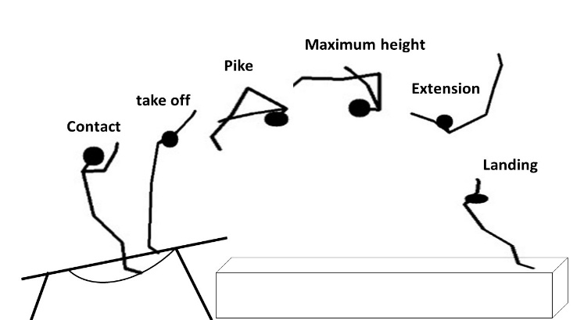

**Figure (3)** Skill phases

**3- Results and discussions**

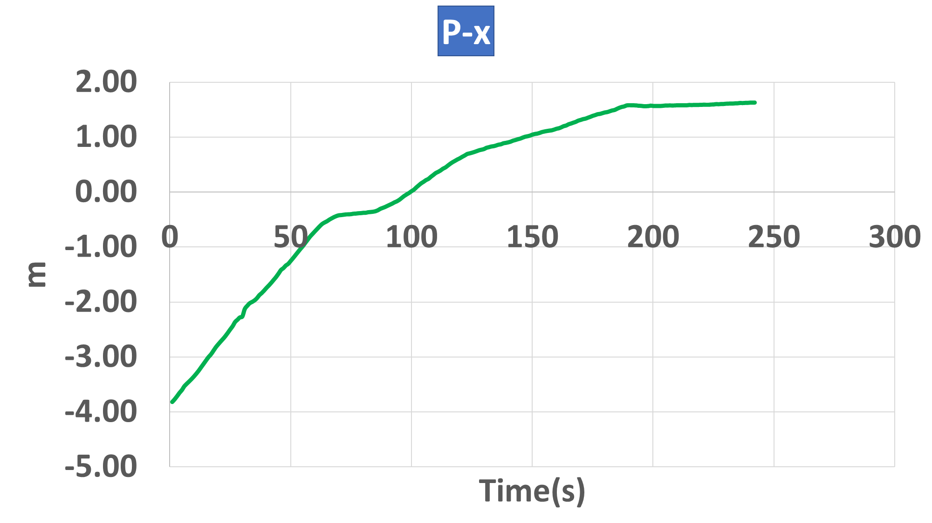

**Figure (4)** Horizontal position

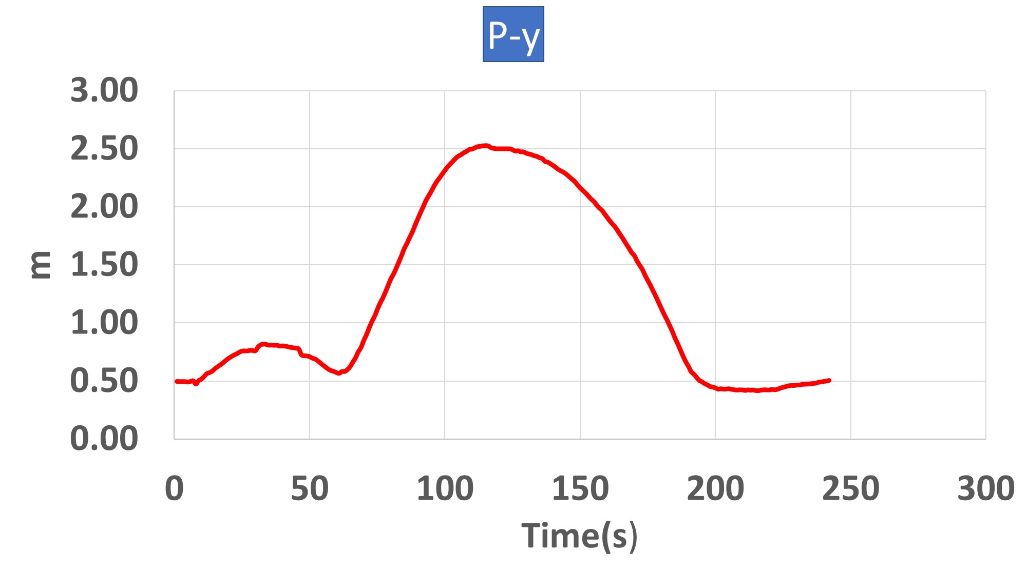

**Figure (5)** Vertical position

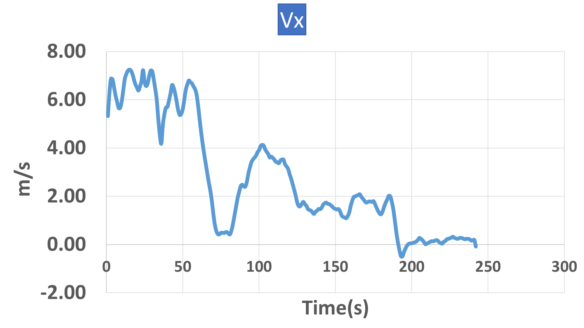

**Figure (6)** Horizontal velocity

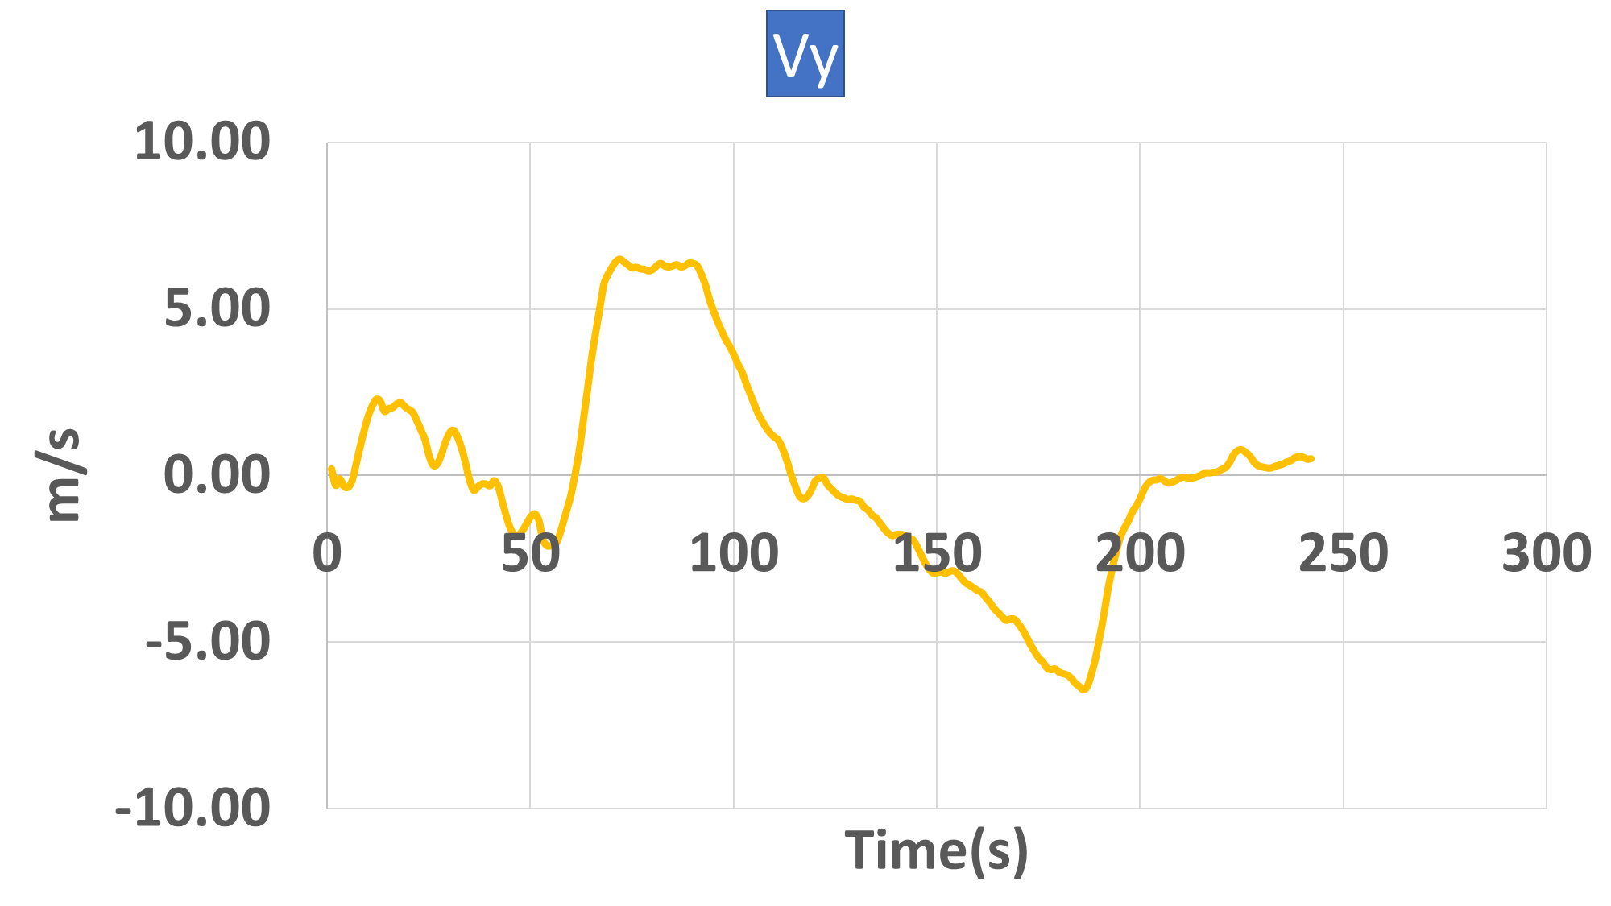

**Figure (7)** Vertical velocity

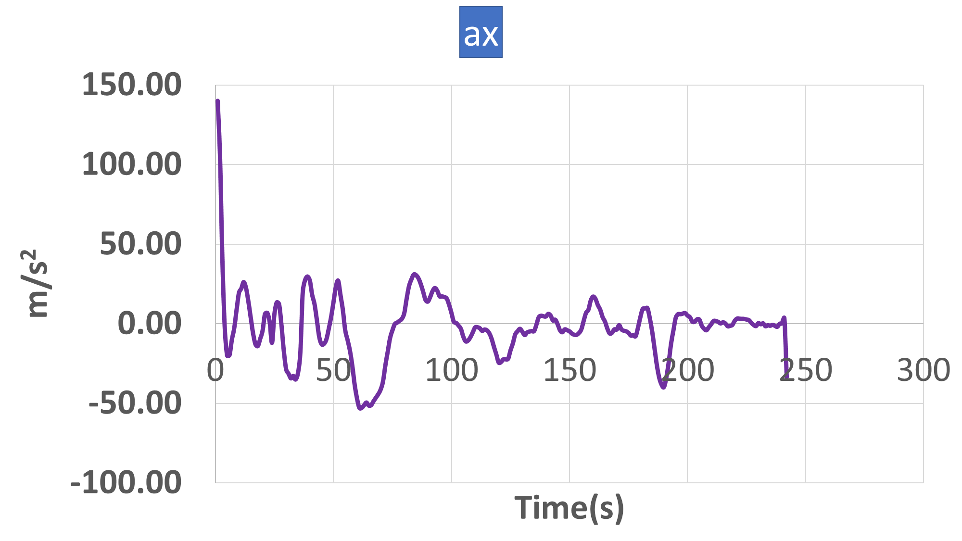

**Figure (8)** Horizontal acceleration

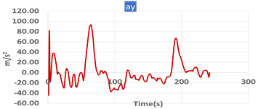

**Figure (9)** Vertical acceleration

|  |  |  |  |  |  |  |
| --- | --- | --- | --- | --- | --- | --- |
| Phases | Position (m) | | Velocity (m/s) | | Acceleration (m/s2) | |
| Horizontal | Vertical | Horizontal | Vertical | Horizontal | Vertical |
| Contact | -1.09 | 0.68 | 6.63 | -1.93 | 18.00 | -15.85 |
| Take off | -0.40 | 1.17 | 0.49 | 6.25 | -0.18 | -3.97 |
| Pike | 0.12 | 2.39 | 4.10 | 2.76 | -1.14 | -32.48 |
| Maximum height (CM) | 0.45 | 2.53 | 3.49 | 0.05 | -3.62 | -29.51 |
| Extension | 1.06 | 2.12 | 1.47 | -2.94 | -6.91 | -2.42 |
| Landing | 1.55 | 0.77 | 1.76 | -6.32 | -26.11 | 28.79 |

**Table N°1: Positions, horizontal and vertical velocities, horizontal and vertical acceleration of the center of mass for the forward pike flip skill on a mini trampoline**

It is clear from Table No. (1) and Figures Nos. (4)(5)(6)(7)(8)(9) as follows:

**3.1- Contact Phase:**

At that moment, the player contacts the mini-trampoline with relatively high horizontal speed rates acquired from the approach phase that precedes the skill, and with a vertical displacement represented by the height of his body’s center of gravity from the ground only during contact, and with a very small horizontal displacement from his point of contact with the ground. There is almost no vertical speed at this stage because it is the moment of his contact with the mini-trampoline, and these values ​​are what are used in the phase of breaking contact and rising.

**3.2- take off Phase:**

The decrease in displacement values on the horizontal axis and their increase on the vertical axis, as well as the convergence of speeds on the horizontal and vertical axes, is a natural matter that contributes to achieving appropriate launch angles at this moment and at convergent speeds on the horizontal and vertical levels, because the push or ascent passes through the center of gravity of the body on the horizontal and vertical axes (eccentric push), which helps the player to perform the rotation (pike) from the highest vertical displacement, and this is confirmed by the values of the vertical and horizontal displacements, as the player can invest the energy transferred from the horizontal speed during the moment of contact and convert it into speed and propulsion force at the moment of breaking contact to increase the acceleration of the body upwards so that the player can complete the rotation at the moment of pike. Because the push or take off passes through the center of mass line on the horizontal and vertical axes (eccentric push), this helps the player to perform the rotation (curved) from the highest vertical displacement, and this is confirmed by the values of the vertical and horizontal displacements, as the player can invest the energy transferred from the horizontal speed during the contact phase and convert it into speed and propulsion force in the take off phase to increase the acceleration of the body upwards so that the player can complete the rotation in the curved phase[6].

**3.3- Pike Phase:**

A noticeable increase on the horizontal level is accompanied by a speed of the body’s center of gravity on the same axis, with a continued increase in the values ​​of vertical displacement and a decrease in the values ​​of speed on the same axis,[7] as this contributes to the completion and success of the pike process, and this is consistent with the nature of the skill performance at this moment[8].

**3.4- Maximum height (CM) Phase:**

The average vertical displacement values at this stage play the biggest role in order to complete the pike and rotation from the highest point, reaching approximately the center of gravity of the body[9]. This is confirmed by the average speed values at that moment, because there is almost no speed at this moment (the dead point). Rather, the pike and rotation require a high speed on the horizontal level to cause the rotation in the direction of the horizontal component.[10]

**3.5- Extension Phase:**

The horizontal displacement of the center of gravity of the body began to increase and rise at a high speed in the direction of the horizontal and vertical component in order to overcome the increase in inertia resulting from the rotational speed at that moment, as well as the occurrence of this speed under the influence of gravity,[12] which contributed to increasing the horizontal displacement and decreasing the vertical displacement to reduce the angular speed of the body parts.[13]

**3.6- Landing Phase:**

At the moment of touching the ground and landing, the horizontal displacement continues to increase and the vertical displacement values ​​decrease. We also find a decrease in the value of the horizontal speed and the vertical speed to achieve a successful landing, as the general function of the final stage of the movement is summarized in slowing down and breaking the movement of the body as a whole by consuming the remaining amount of movement and converting it through the angular change of the body parts into a state of relative stillness and then restoring the lost balance.[14]

**Conclusion:** It would be suggested increase the vertical velocity at take off instant and train to control the limbs elaborately in the air.

**References**:

1. Burke, D. (2015). *The mechanics of the contact phase in trampolining* (Doctoral dissertation, Loughborough University).
2. RAO, C. R. (2014). *BIOMECHANICAL ANALYSIS OF TAKEOFF PHASE OF NATIONAL LEVEL FOSBURY FLOPPERS* (Doctoral dissertation, Acharya Nagarjuna University).
3. Al-Haroun, M. R. (1980). *Three dimensional cinematographic analysis of selected full twisting movements in gymnastics*. Indiana University.
4. Jiang, L., Chen, X., Gao, X., Li, Y., Gao, T., Sun, Q., & Huo, B. (2025). Biomechanical Factors for Enhanced Performance in Snowboard Big Air: Takeoff Phase Analysis Across Trick Difficulties. *Applied Sciences*, *15*(12), 6618.
5. Kong, P. W., Sim, A., & Chiam, M. J. (2022, June). Performing meaningful movement analysis from publicly available videos using free software–A case of acrobatic sports. In *Frontiers in Education* (Vol. 7, p. 885853). Frontiers Media SA.
6. Hassan Abd El Basset, F. (2014). The Effect of Suggested Exercise of the Motor Compatibility upon the Effective Technique for Basketball Juniors. *Journal of Applied Sports Science*, *4*(2), 161-166.
7. Swafford, A. P., Hollister, N., McDonald, S., & Mercer, J. A. (2025). Advancing Circus Biomechanics and Physiology Research with Wearable Technology: Challenges and Recommendations. *Applied Sciences*, *15*(7), 3981.
8. Charbonneau, E., Sechoir, L., Pascoa, F., & Begon, M. (2024). Should all athletes use the same twisting strategy? The role of anthropometry in the personalisation of optimal acrobatic techniques. *Sports Biomechanics*, 1-21.
9. Yeadon, M. R. (2018). Airborne movements: Somersaults and twists. In *Handbook of human motion* (pp. 1661-1679). Springer, Cham.
10. Alikhani, R., Shahrjerdi, S., Golpaigany, M., & Kazemi, M. (2019). The effect of a six-week plyometric training on dynamic balance and knee proprioception in female badminton players. *The Journal of the Canadian Chiropractic Association*, *63*(3), 144.
11. Hayes, W. C., Erickson, M. S., & Power, E. D. (2007). Forensic injury biomechanics. *Annu. Rev. Biomed. Eng.*, *9*(1), 55-86.
12. Tilley, D., & James, D. A. (2019). Rehabilitation of gymnasts. In *Gymnastics Medicine: Evaluation, Management and Rehabilitation* (pp. 233-290). Cham: Springer International Publishing.
13. Sayyah, M. (2017). *Variability and control in springboard diving* (Doctoral dissertation, Loughborough University).
14. Ranieri, M., Potter, M., Mascaro, M., & Grant-Ford, M. (2019). Return to play in gymnastics. In *Gymnastics Medicine: Evaluation, Management and Rehabilitation* (pp. 291-343). Cham: Springer International Publishing.
15. Charbonneau, E., Sechoir, L., Pascoa, F., & Begon, M. (2024). Should all athletes use the same twisting strategy? The role of anthropometry in the personalisation of optimal acrobatic techniques. *Sports Biomechanics*, 1-21.